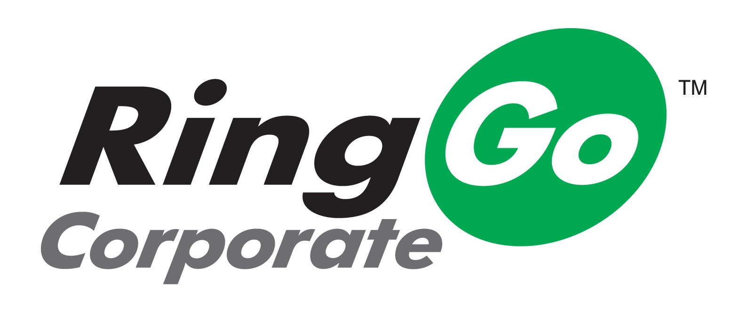
Using RingGo Corporate for Business Parking
RingGo Corporate is a service for employees that drive and park regularly for business. Rather than paying with cash at a pay and display machine and then claiming this money back on expenses, RingGo Corporate lets nominated employees park on a business account in RingGo-enabled parking areas instead.
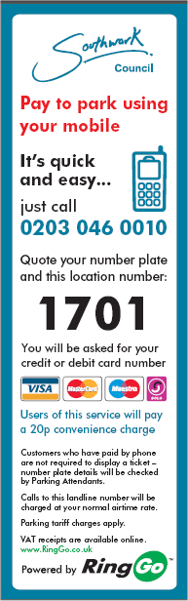
How Do You Park with RingGo Corporate?
When you park on business in a RingGo-enabled parking area, simply look for the signs like the one on the left, with a RingGo logo.
Call the RingGo number shown eg 0203 046 0010 using the mobile phone you use for business.
This number will be quickly matched against the account details provided to RingGo and you will be validated as an authorised user of RingGo Corporate.
Once your details are verified, you will be asked for the location code where you are parked – in this case, it’s 1701.
When you reach the payment stage of the call, the system automatically offers you the option to pay with RingGo Corporate, so if you are parking for business, select this option.
Your parking session starts as soon as you have chosen to park with RingGo Corporate. You will automatically receive a text summary confirming your booking. This and the parking fee are charged direct to the RingGo Corporate Account.
With RingGo parking you don’t receive, or need to display, a parking ticket. Parking Attendants check that vehicles are validly parked using an internet-connected handheld device which accesses the RingGo database in real time.
Ten minutes before your parking is due to expire you will receive a text reminder that your parking is about to run out. If you are held up or running late, should the parking rules allow it, you can top up your parking without returning to the car. Simply call up the RingGo number again (you can retrieve it from your “dialed numbers” or save it in your phone book) and the service will ask you how much longer you want to stay.
If there is no RingGo-enabled car park near where you need to park on business, please pay and claim as normal.
Frequently Asked Questions
How do I know if I am a nominated RingGo Corporate user?
If you are a nominated RingGo Corporate user, you should have received a notification e-mail from your RingGo Administrator, providing information about the service.
If you haven’t been told you are a nominated RingGo Corporate account employee
If you drive frequently on business, park in car parks covered by the RingGo service and think you should be on the RingGo Corporate plan, please in the first instance, raise this with your Manager who should then contact the RingGo Corporate Administrator.
I tried using RingGo Corporate in a parking area, but it didn’t work
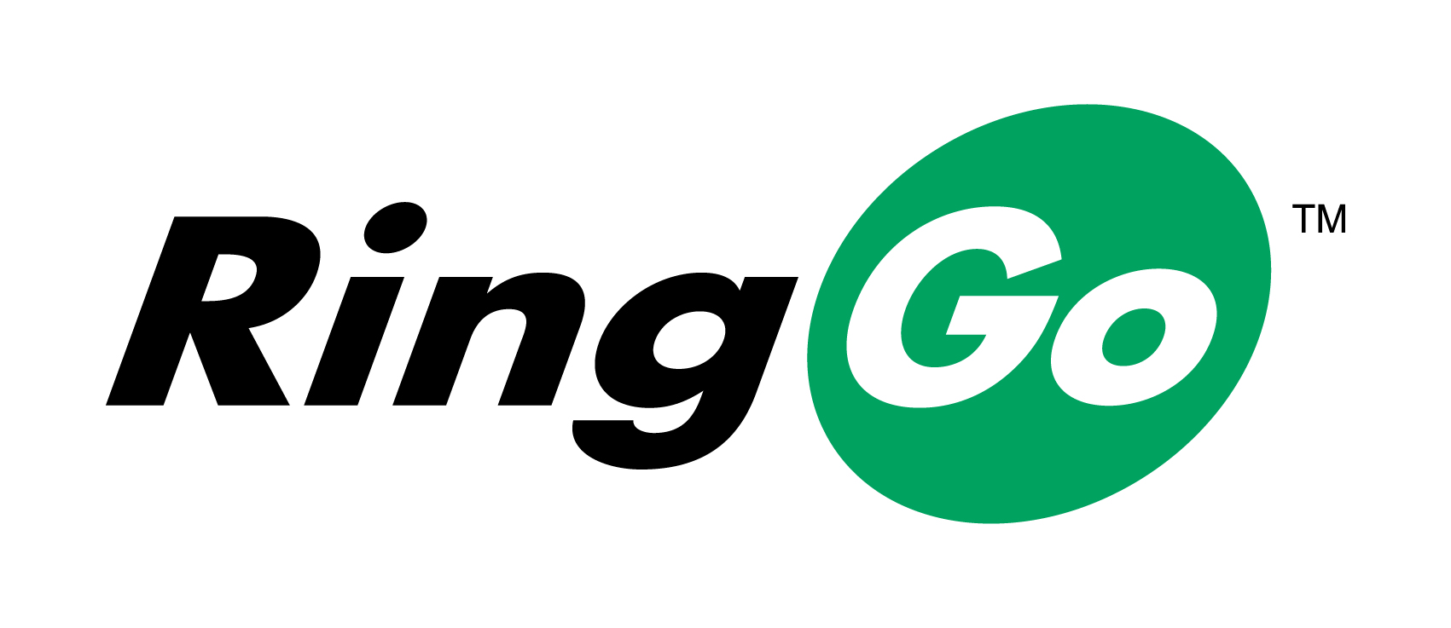
If you are sure it was a RingGo parking area and the service didn’t work please contact your RingGo Corporate Administrator who will check that you are correctly set up for the service.
The easiest way to check that a site is RingGo-enabled is to search on www.myRingGo.com/whereitworks. Or, if you’re in the car park, just make sure that the signs around the parking area have the RingGo logo on them (see right).
I want to use RingGo for non-business parking, can I do this?
Yes – you can register as a personal user of RingGo on-line at www.myRingGo.co.uk or when you want to park. Either confirm ‘no’ to using RingGo Corporate when you are offered this as a payment option or use your personal mobile phone for the call. This will automatically start you on the registration process as a personal user and you will be asked to provide your credit or debit card details for payment.
Other questions
If you have any other questions about the service, please visit the RingGo on-line help centre at http://help.MyRingGo.co.uk and click on the ‘Corporate’ help section.
More information about RingGo and RingGo Corporate
For more general information about RingGo and RingGo Corporate, please see www.RingGo.co.uk

